DATA LEAKS
IMPORTANCE OF SOC IN THE CRISIS
What is data? [In enterprise context]
Data in an enterprise context refers to the collection of raw facts, numbers, records, and digital information an organization generates, collects, and stores

Categories of data
-Transactional Data- Records of daily business events
-Master Data: The core entities of a business that dont change often
(employee lists, product catalogs, and vendor information)
-Analytical Data: Historical information of a company used to spot trends and use in decision making or business intelligent
-Unstructured Data: emails, internal documents (Memo) , audio files, social media review

The Data Lifecycle
To use data effectively, modern enterprises implement strict Data Management frameworks (such as those outlined by DAMA International) to govern the entire data lifecycle:
- Collection: Gathering facts from apps, IoT sensors, and user interactions.
- Storage: Organizing data into Data Warehouses or Data Lakes for easy retrieval.
- Governance: Setting security protocols, access controls, and compliance rules (like GDPR or local privacy laws).
- Analysis: Using AI/Machine Learning and BI tools to turn raw facts into actionable insights
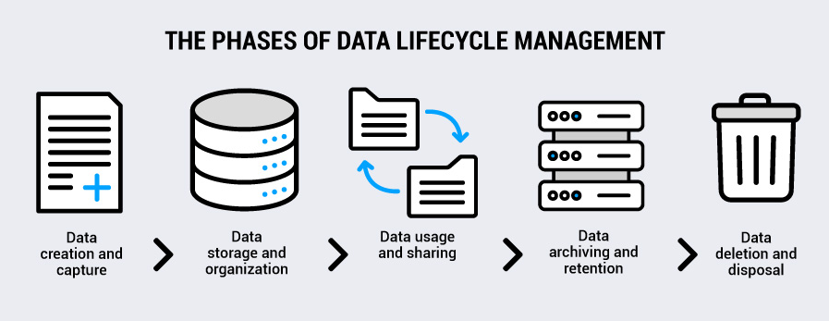
What are data leaks?
Data leaks (accidental exposure) and data breaches (malicious theft) involve several key technical terms used by security professionals to describe how sensitive information is exposed

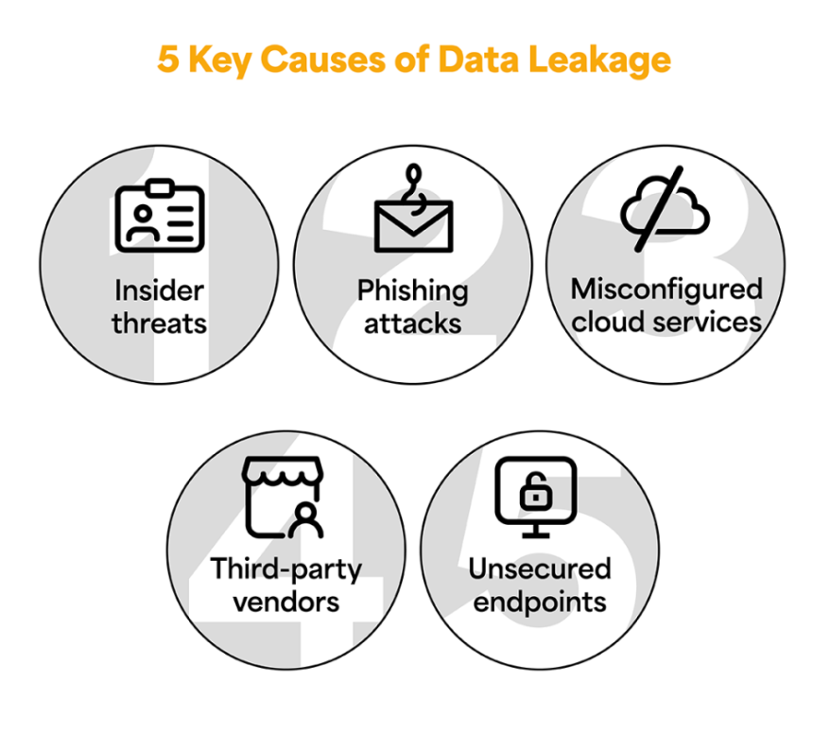
Effects of data leaks
What can be done with stolen-data
Laws surrounding Data leaks
Standards to prevent data leaks

Types of Cyberattack that leads to data leaks

